**Metadata profiles in DAM in AEM 6.3**

There are a lot of Assets in a project and metadata is important to search in assets.

* Metadata profiles are used for adding additional properties to the assets.
* Any additional tabs & fields can be added via metadata profiles.

Steps involved.

1. Create Metadata profile.
2. Update the fields or add new fields.
3. Apply the metadata profile to the folder (so that the assets which will be uploaded under this folder, would see a new set of added fields as well along with existing fields).

Note: Metadata profile field changes can’t be seen on the existing assets. We should run a workflow called “**Dam Update Asset** “. In Dam update asset,the process step named **“Metadata Processor”** adds the metadata profile of that image.

A Metadata Profile lets you apply default metadata to assets within a folder. Create a Metadata Profile and apply it to a folder. Any asset that you subsequently upload to the folder inherits the default metadata that you configured in the Metadata Profile.

**How to create Metadata Profile:**

* Go to Tools-> Assets-> Metadata Profiles
* Create a metadata profile.

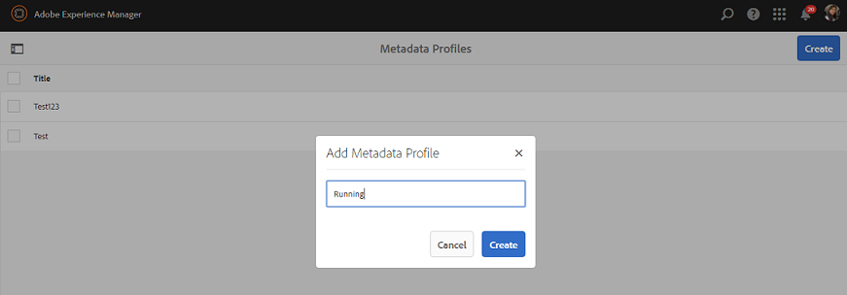

* The metadata profile will be opened with different widgets.

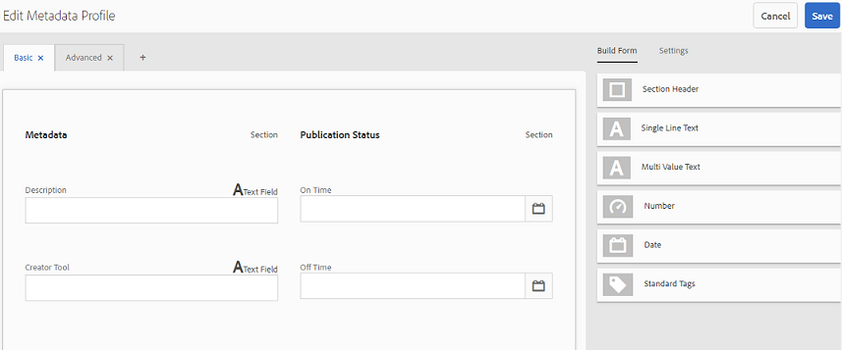

There are multiple widgets that can be added to a profile:   
   
 - Section Header

- Single Line Text

- Multi Line Text

- Number

- Date

- Standard Tags

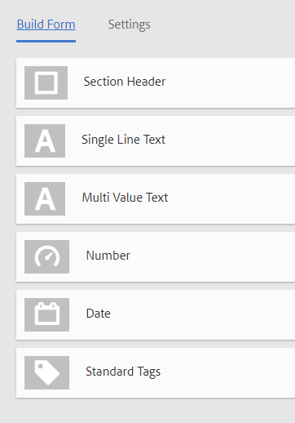

A widget needs these options to be filled.

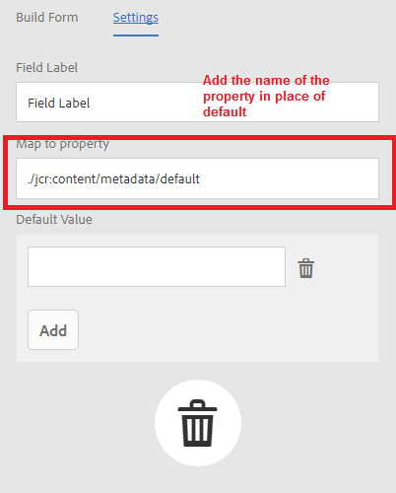

**Where all metadata profiles get stored?**

All metadata Profiles can be seen here **“/conf/global/settings/dam/adminui-extension/metadataprofile**” like this:

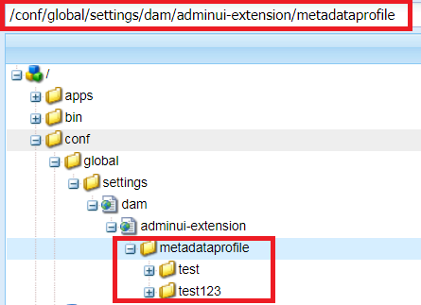

**How to apply Metadata Profile to any dam assets folder?**

When you assign a metadata profile to a folder, any subfolders automatically inherit the profile from its parent folder. This means that you can assign only one metadata profile to a folder. As such, consider carefully the folder structure of where you upload, store, use, and archive assets.

If you assigned a different metadata profile to a folder, the new profile overrides the previous profile. The previously existing folder assets remain unchanged. The new profile is applied on the assets that are added to the folder later.

Folders that have a profile assigned to it are indicated in the user interface by the name of the profile appearing in the card name.

After adding metadata profile to a folder,Under the jcr: content of a folder, you can see the metadata profiles which are attached to that particular folder.

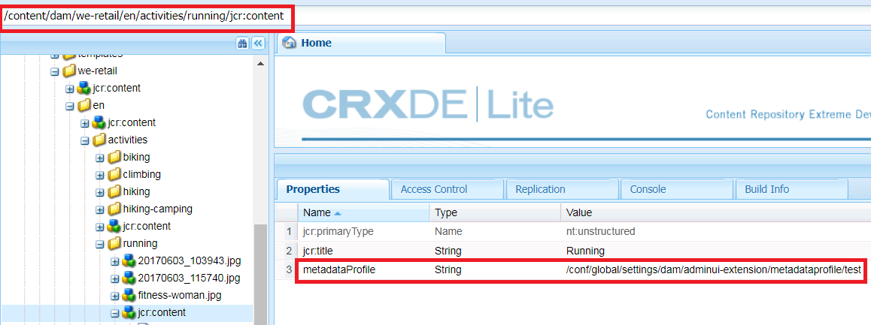

**Note**: If you add something new to metadata profile, the previous existing assets can’t get updated with metadata until we run **“Dam Update Asset”** workflow on them. In Dam update asset,the process step named **“Metadata Processor”** adds the metadata profile of that image.

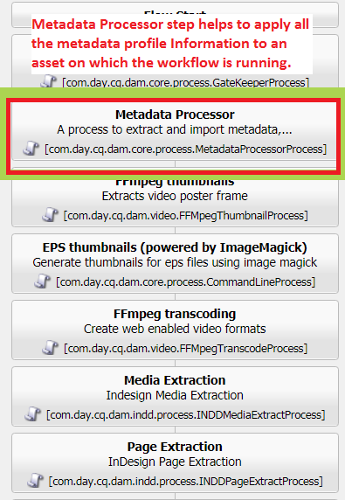

All the metadata profiles need to be added in the **metadata** node of jcr: content each asset.

**Applying metadata profiles to folders from Properties:**

• In the left rail, click/tap **Assets** then navigate to the folder that you want to apply a metadata profile to.

• On the folder, tap or click the check mark to select it and then tap or click **Properties**.

• Select the **Metadata Profiles** tab and select the profile from the drop-down menu and click **Save**

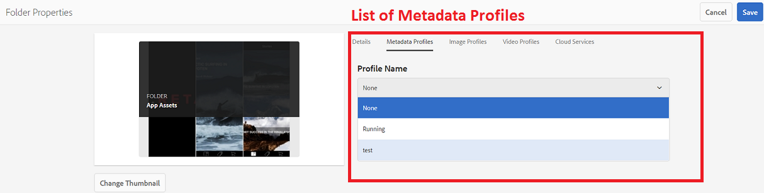

**Applying a metadata profile globally:**

In addition to applying metadata profile to a folder, we can apply a metadata profile globally on the “**/content/dam”** folder from this link <http://localhost:4502/mnt/overlay/dam/gui/content/assets/foldersharewizard.html/content/dam>

In AEM 6.3, If we add “**Standard Tags”** Widget in metadata profile form, add some default values and save it, when we again reopen the form the default values get disappeared.

Actually values get saved in metadata profile but values are not able to be picked up in the console.It was working fine in AEM 6.1. When we compare it with AEM 6.3 , we found out that in AEM 6.1 there is an attribute **data-default** is setting which shows these values, but in AEM 6.3 this **data-default** attribute is not setting.  
  
To solve this issue, we need to overlay “/libs/granite/ui/components/coral/foundation/form/autocomplete/render.jsp” with the following changes.  
  
**After Line 132,** add

|  |
| --- |
| String str = cfg.get("default", ""); |

**After line 157**, add

|  |
| --- |
| attrs.add("data-default", str); |

So you need to make these two changes and things will work fine for you.